

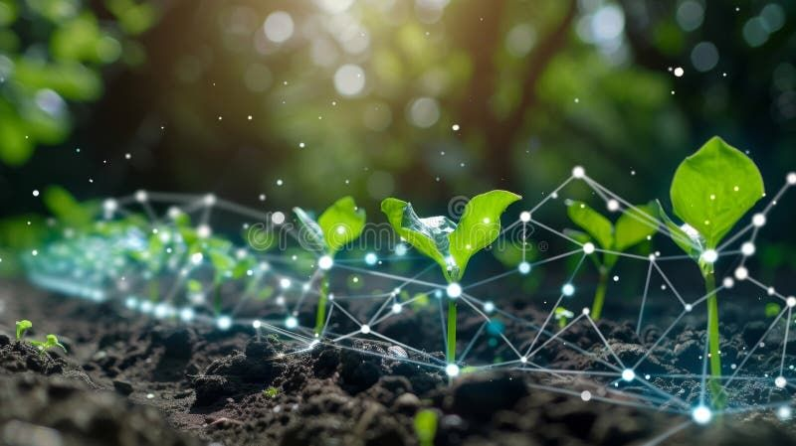
hh
Task: Soil Monitoring System(ARC)
Group 7
Information Systems 325
Group Members:
Olethokuhle Masango(4314391), Madhuri Khanani Ngwenya(4306005), Logan Minnaar(4354381), Kyle Edom(4348792), Niyaaz Gallant(4342262), Bulela Mpetsheni(4344563)

- Executive Summary
The Agricultural Research Council (ARC) is an organization in South Africa that focuses on improving agriculture through research and innovative technology. ARC is dedicated to promoting sustainable farming practices that protect the environment while increasing productivity. The organization collaborates with universities, colleges, and research institutions to develop new technologies that benefit farmers and the agricultural sector in South Africa.
One such innovation is the IoT-Soil Monitoring based system for farming, which is designed to help farmers and monitor soil health and care for crops more effectively. This project is part of ARC’s larger Smart Agriculture Programme, which aims to integrate digital tools into farming. The main goals of this program are to track soil conditions, optimize irrigation, and support informed farming decisions, ultimately making agriculture more efficient, sustainable, and productive.
This project focuses on designing and developing a Low-Energy Soil Monitoring System that measures key soil parameters, including moisture, temperature, pH, electrical conductivity, and essential nutrients like nitrogen, phosphorus, and potassium. The system is intended to provide real-time, accurate soil data to help farmers make informed decisions. The project uses an ESP32 microcontroller as the ‘brain’, Soil Multi-Parameter sensor, RS485 Module, Female-to-Female Jumper cable, and an I2C LCD display to collect and present the data efficiently. By integrating energy-saving techniques and automated measurements, this system reduces manual effort and supports sustainable agricultural practices.
- Introduction
Soil health is a critical factor in agriculture, affecting crop growth, yield, and sustainability. Traditional soil monitoring is often time-consuming, manual, and prone to errors. This project introduces a low-cost, automated solution that continuously monitors soil conditions and displays the results for immediate analysis. The system combines modern IoT technology with user-friendly interfaces, enabling stakeholders to monitor soil health without the need for complex equipment.
- Problem Statement
Farmers and agricultural researchers face challenges in consistently monitoring soil conditions. Manual testing methods are labor-intensive, slow, and often provide delayed results, which can lead to poor crop management decisions. Additionally, many small-scale farmers lack access to affordable and reliable soil monitoring tools. Without timely data on soil moisture, nutrient content, and other critical parameters, crop productivity and soil sustainability can suffer. This project addresses the need for an automated, real-time, and cost-effective soil monitoring solution.
- Project Objective
The main objective of this project is to develop a fully functional, low-energy soil monitoring system capable of measuring and displaying soil moisture, temperature, pH, electrical conductivity, and nutrient levels [Nitrogen(N), Phosphorus(P), Potassium(K)] in real time. The system aims to provide accurate, accessible, and actionable data to farmers and researchers, helping them make informed decisions for soil management. Additionally, it aims to demonstrate energy efficiency and affordability, making it suitable for small-scale agricultural applications.
- Project Scope
The project includes the design, development, and testing of a soil monitoring device using an ESP32 microcontroller as the ‘brain’ and connected sensors. It covers real-time data collection, display on an I2C LCD screen, and optional data logging for analysis. The project focuses on key soil parameters essential for crop health but does not include advanced automation features like automatic irrigation. The system is designed for small to medium-scale agricultural fields and educational purposes. Limitations include battery life constraints and the need for sensor calibration for optimal accuracy.
- Tool, Equipment and Technologies
The Soil Monitoring System makes use of both hardware and software components that work together to collect, process, and display soil data in real time. Each tool and technology was carefully selected to ensure accuracy, reliability, and energy efficiency. Below is a detailed description of the tools, equipment, and technologies used in this project:
- Soil Multi-Parameter Sensor::
This sensor is designed to measure multiple soil parameters/properties at once and they include:
a.) Moisture: Measures how much water is in the soil.
b.) Temperature: Measures the warmth of the soil.
c.) pH Level: Measures the acidity/alkalinity in the soil or of the soil.
d.) Electrical Conductivity: Measures how well the soil conducts electricity.
e.) Nutrients: Measures the Nitrogen(N), Phosphorus(P) and Potassium(K) in the soil.
- ESP32 Microcontroller(Basically the main controller):
The ESP32 Microcontroller is the brain of the system. It basically controls all operations, receives data from the sensors, processes it and sends the results to the LCD display. It supports multiple communication protocols and has built in Wi-Fi for future expansion and consumes very little power.
- RS485 Module:
This module connects the soil sensor to the ESP32. It acts as a communication bridge, converting signals between the Multi-Parameter Sensor and the microcontroller. RS485 is used because it supports long-distance, noise-resistant data transfer which is ideal for outdoor agricultural environments.
- 16x2 LCD Display (I2C)[Display Unit]:
This is a small screen that shows the soil readings in real time. It displays the data in ‘2 screens’, because the screen is too small to display all the data readings/parameters. For example, the first screen displays moisture levels, temperature and ph and the second screen displays EC, N, P, and K levels.
- Female-to-Female Jumper Cables:
These cables are used to connect all the various hardware components(sensor, ESP32, RS485, 12V DC Power Jack and Lcd Display). They allow for easy assembly and modification.
- Power Supply Cable and 12V DC Power Jack:
These hardware components provide electrical power to the system. The 12V DC Power Jack is connected to the sensor and the power supply cable. The 12V DC Power Jack ensures that electricity enters safely into the other hardware components and the Power Supply Cable is the source of electricity.
- Arduino IDE:
This is the programming environment used to write, upload and test the soil monitoring system code. It allows for library management, configure sensors, calibrate the sensor through the code and also controls how the data is displayed on the lcd display.
- MQTT(Message Queuing Telemetry Transport):
This is a lightweight communication protocol that is designed for devices that send small amounts of data over the internet or even a local network. A publish model is used and it makes it simple, efficient and reliable. The ESP32 acts as a publisher, meaning that it collects data from the soil the publishes(sends) the data information to the broker using MQTT. The MQTT broker manages communication between the publisher(ESP32) and the subscriber(Raspberry Pi). The MQTT is used because it works well on low-power, which is ideal for field devices. It ensures real-time data delivery to the data team.
- Raspberry pi(Data Hub):
This component receives real-time data from the ESP32 through the MQTT, making it the subscriber. It stores the data in a ‘database’ and makes it available to the data team. It serves as a mini-computer that can handle multiple connections at once.
- Methodology
The project will follow Agile Scrum methodology with weekly stand-up meetings, sprint planning, and reviews. Stand Ups will be conducted to assess team progress, identify and resolve blockers and to plan next steps. Trello will be used for task tracking. Regular documentation and testing phases will ensure the development aligns with project goals.
- Stakeholder Requirements
The Soil Monitoring System will be developed to meet the needs of key stakeholders such as the Agricultural Research Council(ARC), farmers and maybe the data management team. Each stakeholder group has specific requirements to ensure that the system provides accurate, useful and reliable information for better agricultural decision-making.
- Agricultural Research Council(ARC):
- ARC requires a smart and sustainable system that supports precision agriculture.
- The system must collect accurate soil data readings(Moisture, Temperature, pH, Electrical Conductivity, Nitrogen, Phosphorous, Potassium).
- The data readings should help in improving soil management.

- Farmers:
- The ARC farmers need a simple and affordable device that monitors soil conditions in real time.
- The data readings should be displayed to the farmers in a way that the farmers can quickly understand the soil’s status without needing technical knowledge. For example, the LCD display.
- The farmers can better understand the data readings through a frontend visualization and reading the data interpretations through the visualizations. They should be able to visualize soil trends, soil history trends and current.
- The system must be energy efficient to reduce power consumption.
- Farmers want to receive accurate, reliable and consistent soil data readings to help them make informed decisions about fertilization.

- Data Team:
- The data team requires the soil readings to be sent through the MQTT from the ESP32 to the Raspberry Pi.
- The system must ensure secure and reliable data transfer with minimal data loss to no data loss at all.
- The data will be in a structured format and the data team will send APIS to send back the data to the Soil Monitoring System team so that they can build a frontend that visualizes the soil data readings.
- Risk Management
As every project can face possible challenges that can affect its success, the Soil Monitoring System may also have several potential risks. One major risk was the sensor reading the data inaccurately due to poor calibration. To reduce this risk, we performed calibration tests and the soil multi-parameter sensor was configured with stable calibration values to ensure consistent readings for moisture, temperature, pH, EC, and nutrients(N,P, K).
Another possible risk can be potential power supply interruptions, which could affect data transmission or damage components. This can be managed by using a 12V DC power jack with a reliable power supply cable and enabling the ESP32’s low-power (light sleep) mode to save energy and ensure longer operation in the field.
The loss of data during transmission will be also considered a risk, especially when using MQTT communication. To prevent this, a stable MQTT broker and reliable Wi-Fi connection will be configured to ensure that data is consistently published from the ESP32 and received by the Raspberry Pi.
There was also a hardware connectivity risk, where loose jumper cables or poor wiring could interrupt sensor readings. This was minimized through secure wiring, labelled connectors, and testing of each connection before deployment.
Finally, the risk of environmental damage is also possible, like water exposure or overheating may be managed by ensuring the components are placed in protective casings and kept away from direct exposure to harsh weather conditions.
- Deliverables and Benefits
Main deliverable:
- A fully functional IoT-based soil monitoring system that measures and displays soil parameters (Moisture, Temperature, pH, EC, N, P, K).
- MQTT communication setup that transfers soil data from the ESP32 (publisher) to the Raspberry Pi (subscriber) for analysis by the data team.
- Technical documentation, including wiring diagrams and setup guides for maintenance and training.
Key Benefits:
- Accurate soil data helps farmers make better irrigation and fertilization decisions.
- Automated data collection reduces manual labor and human error.
- Real-time monitoring allows quick responses to soil health changes.
- Energy-efficient design increases system lifespan and lowers operational costs.
- Scalable and flexible: the system can later integrate with cloud platforms or mobile dashboards for advanced analytics.

- Conclusion
The Soil Monitoring System project successfully demonstrates how IoT technology can be applied to improve agricultural practices in South Africa. By combining hardware components like the ESP32 microcontroller, soil sensors, RS485 module, and LCD display with communication tools such as MQTT and Raspberry Pi, the project provides a complete digital solution for soil health monitoring.
The system aligns with the Agricultural Research Council’s (ARC) vision of Smart Agriculture, promoting data-driven and sustainable farming. It provides accurate soil information that helps farmers use water and fertilizers more efficiently, leading to healthier crops and higher yields.
Overall, the project not only supports farmers but also contributes to building a foundation for modern, technology-based agriculture in rural areas. With further development, this system can be expanded to include cloud integration, weather sensors, and mobile applications moving one step closer to a fully connected and intelligent farming environment.

